Fake Profiles Detection across Online Social Networks using Neural Network

Abstract
Mobile phones use is increasing day by day. Recent technology is mainly associated with online social networks, which have emerged as a part of everyone's life in terms of making new friends and retaining friends, as well as making their hobbies easier. However, the increase in online networking causes various problems, such as fabricating their profile. In this research, we employ computing device learning, specifically a synthetic neural community, to identify whether or not a Facebook/ Twitter buddy request is genuine or fake. This work uses Artificial Neural Networks to identify whether given social network account details are from genuine or fake users. ANN algorithm will be trained with all previous users fake and genuine account dataset and then whenever we gave new test data then that ANN trained model will be applied on new test data to identify whether given new account details are from genuine or fake users. Online social networks such as Facebook or Twitter contain user’s details and some malicious users will hack social network database to steal or breach users’ information, to protect users’ data we are using ANN Algorithm.
Keywords: Online social media, Fake Profiles, Artificial Neural Network, Recent Technology.

INDEX
CHAPTER1: INTRODUCTION
1.1Aim of paper:
1.2 Objective of paper:
1.3 Scope of study
1.4 Introduction
CHAPTER 2: LITERATURE SURVEY
CHAPTER 3: EXISTING METHOD
3.1 Disadvantages:
CHAPTER4: PROPOSED WORK
4.1 Methodology
4.2 Limitations:
4.3 Advantages
4.4 ANN algorithms details
4.5 Module Details
CHAPTER 6: HARDWARE AND SOFTWARE REQUIREMENTS
CHAPTER 5: RESULT
CHAPTER 6: APPLICATIONS
CHAPTER 7: CONCLUSION
REFERENCES
APPENDIX
PYTHON

LIST OF FIGUERS

Fig. 1.1 Cycle of detection
Fig.1.2 Identifying Fake Profile in Online Social Network
Fig.3.1 Proposed Method
Fig.3.2 Class diagram
Fig.3.3 Use Case diagram
Fig.3.4 Sequence diagram
Fig.5.1 Upload Social Network Profiles Dataset
Fig.5.2 selecting and uploading ‘dataset.txt’ file
Fig.5.3 dataset loaded and displaying few records
Fig.5.4 dataset contains total 600 records
Fig.5.5 after 200 epoch ANN got 98.33% accuracy
Fig.5.6 ANN model generated
Fig.5.7 ANN Iteration wise accuracy and loss graph
Fig.5.8 selecting and uploading ‘test.txt’ file
Fig.5.9 uploaded test data and after square bracket

CHAPTER 1
INTRODUCTION
  - Aim of paper :
The aim of the paper "Identifying Fake Profiles across Online Social Networks using Neural Network" is to develop and evaluate a neural network-based system for accurately detecting and identifying fake profiles on various online social networks. The ultimate goal of the paper is to provide a robust, accurate, and generalizable solution for identifying fake profiles on online social networks, leveraging the power of neural networks to enhance the security and integrity of social platforms.
  - Objective of paper:
The objective of the paper "Identifying Fake Profiles across Online Social Networks using Neural Network" is to develop a neural network-based system that accurately detects and identifies fake profiles on various social networks. This involves enhancing detection accuracy by analyzing complex patterns in user data, identifying key distinguishing features, and minimizing false positives and negatives. The paper aims to create a scalable and adaptable model that generalizes well across different platforms, ensuring practical real-world implementation while addressing privacy and ethical considerations. t finds the hyperplane to classify the data. Neural networks and SVM can accept a large amount of random data and are suitable to detect fake accounts on social networking sites based on various characteristics of accounts. The naive Bayes classifier is based on Bayes' theorem.
1.3 Scope of study
To developing neural network models to accurately detect fake profiles by analyzing user activity, content patterns, and network interactions. It involves collecting and preprocessing large datasets from various social networks, designing and evaluating neural network architectures, and comparing the performance with existing detection methods. The study also addresses the scalability of the solution for real-world application and ensures adherence to privacy and ethical standards.
1.4 Introduction
Long range interpersonal communication has end up a notable diversion inside the web as of now, drawing in countless clients, burning through billions of minutes on such administrations. Online Social organization (OSN) administrations assortment from social cooperations based stages like Facebook or My Space, to understanding spread driven stages suggestive of twitter or Google Buzz, to social association trademark brought to introduce frameworks like Flicker.
The contrary hand, improving security concerns and safeguarding the OSN privateness actually connote a most significant bottleneck and saw mission. While utilizing social organization's (Sn's), exceptional people share stand-out amounts of their private arrangement. Having our singular expertise totally or to some degree uncovered to the overall population, makes us amazing focuses for exceptional kinds of attacks, the most exceedingly terrible of which could be ID burglary.
Data fraud happens when any singular uses character's skill for a private achieve or reason. During the prior years, online recognizable proof burglary has been an essential issue thinking of it as impacted huge number of individuals around the world. Casualties of ID robbery might experience remarkable sorts of punishments; for delineation, they would lose time/cash, get dispatched to reformatory, get their public picture destroyed, or have their associations with partners and friends and family harmed.
Malware is a universal concept for all types of software attacks. With the fast growth of technology, malware is one of the most significant security threats [1]. Any program designed to infiltrate or harm a computer system with infecting a legitimate user’s computer, such as information stealing or spying is considered a malware. Malicious software can be categorized into different classes depending how they attempt to harm or behave such as Trojan, Virus, Rootkit, Worm and Spyware [13]. While the family of malware is developing, anti-virus detectors seem unable to satisfy critical requirements, appearing in millions of computer software being threatened.

According to Kaspersky Labs in the year of 2018 1, there was about 5.638.828 different hosts that were attacked. A further article by Juniper Research 2 noticed that more than 33 billion records will be stolen by cybercriminals in 2023 alone. Nowadays, detection of malware is challenging due to the high accessibility of attacking methods on the Internet. Additionally, the high availability of anti-detection methods which gives everyone the chance to originate an attack or malicious software without a certain level of experience. Moreover, attackers are using methods to immediately upgrade to a newer version in a short period of time to avoid detection methods . Therefore, malware protection of computer systems is one of the most fundamental tasks for users and organizations, since even a single attack can result in serious damages to data and severe losses.
Huge losses and frequent attacks impose the need for reliable and accurate techniques for detection. Malware detection is divided into static analysis, which means the analysis of a compiled file or program and dynamic analysis that means analyzing the run time behavior such as battery consumption, memory reads and writes, and network utilization of the device [2]. Static analysis concerns about reading the source code of malware without the execution of the program file, it tries to find the behavioral attributes of the file such as file format inspection, string extraction, AV scanning, fingerprinting, and disassembling of the binary format.
The dynamic analysis depends on actual-time monitoring of the file while it is being executed, running in a virtual environment. Malware detection techniques can also be divided into signaturebased and heuristics-based [6]. However, the accuracy in this method is not always adequate for detection, resulting in a lot of false-positives and false-negatives. The need for a new detection method is becoming urgent. For this reason, machine learning-based techniques can be invaluable to the safety of the system. Machine learning models can be trained to classify the malware into infected execution and legitimate execution. Malicious software examination requires powerful detection abilities for deciding whether a suspicious file is malicious or not.
Accounts in online social media have heaps of input data like name, sexual orientation, companions, devotees, preferences, area numbers. Half part of this input data are both of public and private. We have to use input that are public to know profiles which are phony for interpersonal organization as data from private is unavailable. In any case, on the off chance that our proposed plan is utilized by the interpersonal interaction organizations itself, at that point they can utilize the private data of the users to know not from abusing from security issues. Considered data is highlights for profiles to classify of phony and genuine profiles.
For detecting fake profiles we followed these steps:
1. Functions are to be selected after choice of attributes, the ataset of profiles which are already classified as fake or real are wanted for the schooling motive of the classification algorithm. We have used a publicly available dataset of 1337 fake customers and 1481 actual users which includes numerous attributes consisting of call, status count, number of friends, fans depend, favourites, languages regarded and so forth.
2. The selected attributes are extracted from profile for the purpose of type.
3. After this the dataset of fake and actual seasoned files are prepared. From this dataset, 80% of both seasoned files (authentic and pretend) are used to prepare a schooling dataset and 20% of both profiles are used to put together a testing dataset.
4. The schooling dataset is then fed to the classification set of rules. It learns from the education dataset and is predicted to offer correct elegance labels for the testing dataset.
5. The labels from the testing dataset are eliminated and are left for determination by the educated classifier.
6. The result of classification algorithm is shown in 4.4. we've got used two classification algorithms and have compared the efficiency of these algorithms. 7. The proposed structure in the figure 1 shows the succession of procedures that should be pursued for persistent location of phony profiles with dynamic gaining from the input of the outcome given by the arrangement calculation
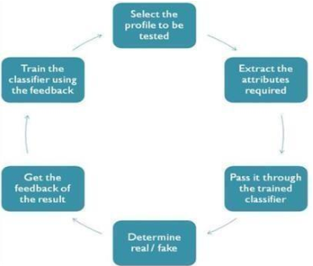
Fig. 1.1 Cycle of detection

It is also used in searching for what family a malware is likely to belong to. Machine learning methods can be used to discover what is a normal act in the beginning, and search for anything that might be far of it. Therefore, it can provide protection for users by keeping systems safe and stop attacks much faster than they had in the past. Numerous machine learning methods are observed to be helpful in malware detection and classification some of these techniques are Random Forest (RF), Support Vector Machine (SVM), Na ̈ıve Bayes (NB), Logistic Regression (LR) and AdaBoost [3]. In our study, we follow the methodology proposed in reference paper [4].
In this paper, the authors experimentations are based on 306 features extracted from actual behavior of the files (Heuristic) observed by a sandbox. They applied machine learning algorithms on 984 malicious files and 172 benign files to perform binary and multi-class classification. The highest accuracy achieved with the Random Forest model 95.69% for multi-class classification and 96.8% for binary classification. In our work, we are using Random Forest classifier to select the most important features and ignore irrelevant features. Thus, we obtained better accuracy than the referenced paper in [4]. Our experimentations show that the highest accuracy that are achieved by Decision Tree is 98.2% for binary classification and the Random Forest achieved 95.8% for multi-classification, respectively. The rest of this paper is organized as follows.
Research ProblemThe concern about fake profile is protecting personal data or information from cyber attacks known as phishing attacks. The cyber attackers are often use this in stealing of information. In detecting of passwords, sharing of irrelevant contents, raising awareness this type of profiles are involved in all unlawful activity. In managing and taking the advantages of the critical situation this can be lead to the anonymity through a longer way. For reducing the incidents like trolling, hacking and cyber bullying this is need to be identified Research RationaleIn securing the all types of social accounts and keeping the users away from the cyber hackers this is necessary to identify those and using of ANNs model this can improved in more better way.
Research ApproachIn regards to this, an "artificial neural network" system has been introduced as a part of the computer system. It is designed for simulating in a way in which the human brain possesses and analyses information. The inductive research approach can be considered for this type. In viewing the existing process and situations this canbe observed through the patterns and system regularities. In taking the technical advantage ANN model need to be used effectively.
It can be described as a foundation of artificial intelligence which will solve the problem in proving the difficulty according to human standards. Therefore "artificial neural networks" (ANNs) are introduced as a process of modeling, allowing the human nervous system through learning technique. By depending on the prediction, this detection process is revealing about the "user-level activities' '. User influence is also vital in reporting about the abnormalities. The social influence upon users can be assessed with the two types of factors. One is to find the user's impact upon others, and the other is to give the user importance. The evaluation is also based on the "fine-grained feature
Neural networks and SVM can accept a large amount of random data and are suitable to detect fake accounts on social networking sites based on various characteristics of accounts. The naive Bayes classifier is based on Bayes' theorem.
Social networking sites have been extensively used as a medium of communication between people in day-to-day life. Users using these sites always share their information and daily activities which attract several people to these sites. The increasing popularity of Facebook or Twitter or Twitter from the year 2006 to 2016 allows the users to add friends and share various kinds of information such as personal, social, economic, educational, political, business, etc. Moreover, they can also share photos, videos, and other day-to-day interaction. However, some people don't use these sites with a good objective. Therefore they create fake accounts on social sites.
Fake accounts do not have any real identity so we can call them Attacker. This attacker uses incorrect information or statistics about some real-world person to create a fake account. Using these fake accounts, attackers spread fake information which affects other users. To protect such sensitive data of users is one of the major challenges of social sites. There are several techniques in the field of machine learning that have been developed to detect fake accounts in social networking sites such as Neural Network (NN), Naive Bayes, Markov Model, and Bayesian Network.
In recent researches, it has been found that these techniques make available enhanced results to detect fake accounts. Neural Network consists of many interconnected processing elements. It takes decisions just like a human brain. Support vector machines (SVM) are supervised machine learning techniques used for classification. It finds the hyperplane to classify the data. Neural networks and SVM can accept a large amount of random data and are suitable to detect fake accounts on social networking sites based on various characteristics of accounts. The naive Bayes classifier is based on Bayes’ theorem. It predicts the probability that a given variable belongs to a particular class.
Nowadays social networking sites have become a wide platform for people to keep in touch with each other, to share information, feelings, photos, posts, status, etc. With the help of OSNs like Twitter, Facebook, Instagram, Pinterest, Google+, LinkedIn, etc. people can easily interact with other people residing in any part of the world. One disadvantage of these sites is that most of the users are unaware of identity theft, loss of privacy, fake profiles, malware, etc. Twitter and Facebook are the most prominent OSNs and are continuously being attacked by spammers to steal personal data, spread rumors, and share false news. These spammers sometimes also use automated programs called social bots that can act like humans and contribute to spread nuisance on the internet.
Another major problem while using social networking sites is the fake accounts created with different intentions such as to entrap or mislead people or spread malicious activities and because of these reasons it has become very important to develop a mechanism to detect spammers.For the purpose to detect fake accounts on the social media platforms the dataset generated was pre-processed and fake accounts were determined by machine learning algorithms.The classification performances of the algorithms Random Forest, Neural Network and Support Vector Machines are used for the detection of fake accounts. The accuracy rates of detecting fake accounts using the mentioned algorithms are compared and the algorithm with the best accuracy rate is noted.
In recent decades, social media has significantly influenced interpersonal relationships, transforming the internet into a virtual platform for online development, trade, and exchanging knowledge by individuals and their organizations [1]. The various social communication systems have value chains aimed at certain user groups. For example, users may reunite with old acquaintances by browsing their Facebook profiles, and social media such as Twitter provides relevant updates and news of the following profiles. On the other hand, there are social network sites with different purposes, like LinkedIn, which is intended to serve as a support system for professional groups. Therefore, users are encouraged to fill their profiles with a significant number of personal data and to explore other users who share the same interests. According to usage rates, Facebook is the most popular social media platform, with 800 million monthly visits [2].
Estimates provided by Cloudmark suggest that between 20 and 40 percent of accounts on both Facebook and Twitter might be fake profiles [3]. It is becoming more challenging to tell a real user from a fake due to the high levels of user engagement that occur every day and the millions of transactions that take place each day. The anticipated outcomes from the efforts to elicit user participation in identifying fake accounts have not been attained [3].

In addition, when it comes to networks that have strict user privacy policies, there is a tiny amount of available public data. Thus, differentiating between fake and valid profile pages has become quite tricky systematically before trusting a possible association. In this piece of work, a way for distinguishing authentic accounts from false accounts in a logical manner is proposed. The approach is based on the limited publicly accessible account data on websites with strict privacy regulations, such as LinkedIn.
Social media’s growth can potentially raise people’s social evaluation and popularity. In particular, social network users may gain popularity by amassing many likes, follows, and remarks. On the other hand, establishing fake profiles is much too simple, and such accounts can be purchased online at little cost. For instance, purchasing followers and comments on social media platforms such as Facebook and Twitter may be done more easily on the internet [4].

Analysis of activity changes is one of the most common techniques open social networking methods use to spot strange accounts. The activities that people engage in throughout time tend to shift and evolve. Therefore, the server can identify a potential scam account by monitoring for sudden changes in access patterns to the content and activity it requires. In case of unsuccessful identification, the deviant might fill the systems with fake information [5]. Fig. 1 demonstrates a common schema of fake account detection on social networks

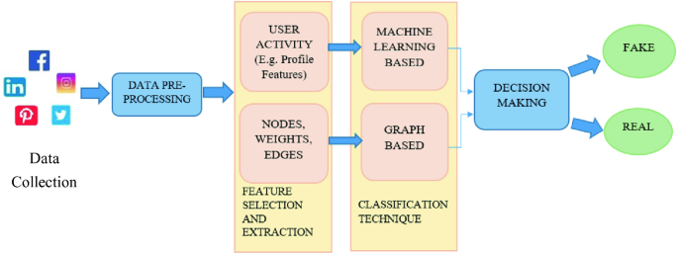
Fig.1.2 Identifying Fake Profile in Online Social Network
In recent years, the widespread use of online social networks has created an environment in which individuals can easily create and maintain multiple profiles. However, some of these profiles may be created with the intention of deceiving others or spreading false information, known as "fake profiles." Detecting fake profiles is a crucial task to maintain the authenticity and trustworthiness of social networks. Machine learning (ML) algorithms and natural language processing (NLP) techniques have emerged as effective tools for detecting fake profiles in online social networks. In this project, we aim to explore the use of ML algorithms and NLP techniques for detecting fake profiles in online social networks.
Our focus will be on identifying the key features that distinguish fake profiles from real ones and building models that can accurately classify profiles as either real or fake. The outcome of this paper can help social networks to improve their security and user trust by eliminating fake profiles. ML algorithms and NLP techniques is multifaceted. Firstly, the presence of fake profiles can negatively impact the user experience of social networks by spreading false information, promoting malicious activities, and compromising user privacy. Therefore, it is essential to develop robust methods to detect fake profiles to maintain the authenticity and credibility of social network.
Online social media is the place each person has a outlook then be able to keep connecting their relations, transfer their updates, join with the people having same likes. Online Social Networks makes use of front end technologies, which permits permanency accounts in accordance with to know each other. Facebook, Twitter are developing along with humans to maintain consultation together with all others. The online accounts welcome people including identical hobbies collectively who makes users easier after perform current friends. Gaming and entertaining web sites which have extra followers unintentionally that means more fan base and supreme ratings.
Ratings drives online account holders to understand newer approaches not naturally or manually to compete more with their neighbours. By these analogies , the maximum famous candidate in an election commonly get more number of votes. Happening of fake social media accounts and interests may be known. Instance is fake online account being sold on-line at a online market places for minimum price , brought from collaborative working offerings. More often feasible to have Twitter fans and Facebook media likes in online. Fake user accounts may be created by humans or computers like bots , cyborgs. Cyborg is half bot and half human account.
These accounts are usually opened by human, but their actions are made by bots. The another reason for people to create fake profiles for defaming accounts they dislike. This type of users create accounts with the username of the people they hate and post irrelevant stories and snap shots on their accounts to redirect everybody so that they assume that particular person is awful and make their reputation low. Most attackers are in it to make money. They make money by distributing unwanted ads (spam) or capturing accounts they can reuse or resale (phishing). Spammers gather resources to know fake and real users, email ids ,ip locations and computing knowledge power.
Every one of these advantages can have a huge expense related with them, and an assault, similar to any business adventure, needs benefit to continue onward. Attackers more often use facebook logins, applications, Events, Group users to gather login credentials, spam users, and ultimately gain profits. They need email records, treats, and a wide scope of IP delivers to go around notoriety based protections. Moreover, they use telephone numbers, taken charge cards, and CAPTCHA arrangements trying to go around validation checks. Facebook security privileges its system to gather users to prevent spams and fishing accounts. Facebook Immune System does continuous minds all gather and each its activity made by it. Social bot is a known that stops and controls social online accounts.
Bots socially is an auto generated software. Precised way a social account duplicates relies upon at the social media, also in contrast to general bot, a social bot interacting more in different customers that the social bot is a actual man or woman. More auto generated programs or semi generated computer programs that duplicate the human behaviour in Social media. So to use them hackers attack online social networks. Thus primarily used for campaign, advertise and also thieve user non-public in more large scales.
The bot online master gather inputs because of attackers.Cyborg bots appear like accounts of human from random calls of human, often selected human users image and user records published more often from collective accounts to be prepare from before online account attackers. Cyborg bots ship gather random users. If a person acknowledge the request from user, ship to get request of the account who agree request, will increase popularity price because of lifestyles of mutual friends.
Neural Network: The conventional method by which a computer works is that you provide instructions or algorithms to the computer and it generates output based on it. But what if you do not know the algorithm to solve a problem? Will your computer still be able to provide solutions. If we use conventional techniques, then the computer will not be able to solve the problem unless you provide some instructions. Here comes the concept of Neural Networks. We can still solve such a problem by training a network as such our program will learn on its own and will provide solution close to a certain accuracy. The term Neural Networks was coined in 1943 but could not be implemented then due to lack of technology. Neural Networks learn by example. Neural Networks are based on biological neurons i.e. brain cells and the way information is processed inside the brain. There are mainly two types of neural networks : 1. Single layer. 2. Multi layer.

CHAPTER 2
LITERATURE SURVEY
- Sai Pooja, G., Rajarajeswari, P., Yamini Radha, V ., Navya Krishna.G., Naga Sri Ram.B., Recognition of fake currency note using convolutional neural networks(2016). International Journal of Innovative Technology and Exploring Engineering, 58-63,8(5).
In this paper, the Automatic Fake Currency Recognition System (AFCRS) is designed to detect the counterfeit paper currency to check whether it is fake or original. The existing counterfeit problem due to demonetization effects the banking system and also in other fields. A new approach of Convolution Neural Network towards identification of fake currency notes through their images is examined in this paper which is comparatively better than previous image processing techniques. This method is based on Deep Learning, which has seen tremendous success in image classification tasks in recent times. This technique can help both people and machine in identifying a fake currency note in real time through an image of the same. The proposed system, AFCRS can also be deployed as an application in the smartphone which can help the society to distinguish between the fake and original currency notes. The Accuracy in the proposed system can be increased through the original fake notes, where as the proposed system contains the images from children’s bank churan label. Automatic recognition of fake Indian currency is very important in major domains like banking nowadays. This system is used to detect whether the currency is fake or original through the auto mated system which is through convolution neural network, in deep learning. Deep learning excels in the task of recognition and classification of images over a large data sets, which is also primarily used in object category recognition. In the recent demonetization drive may be a step towards eradication of corruption and black money, but it fails to address the problem of counterfeit currency. A deep neural network (Figure-1) is a computational model that works in a similar fashion to the neurons in the human brain.
- Mohammed Ali Al-Garadi,Mohammad Rashid Hussain, Henry Friday Nweke, Ihsanali,Ghulammujtaba1,Harunachiro Ma,Hasanalikhattak,Andabdullahgani "Predicti-Ngcyber Bullying On Social Networks.
In seeing the present condition, online social networks are engaging with the majority of the people. From child to adult, all are spending a considerable time on these platforms either by exchanging information or making efficient communication with others. But nowadays, these social networking sites are suffering from a lot of fake accounts in taking advantage of vulnerabilities, either taking the benefits or targeting accounts attempting cybercrimes. Online social media is the place each person has a outlook then be able to keep connecting their relations, transfer their updates, join with the people having same likes. Online Social Networks makes use of front end technologies, which permits permanency accounts in accordance with to know each other. Facebook, Twitter are developing along with humans to maintain consultation together with all others. The online accounts welcome people including identical hobbies collectively who makes users easier after perform current friends. Gaming and entertaining web sites which have extra followers unintentionally that means more fan base and supreme ratings. Ratings drives online account holders to understand newer approaches not naturally or manually to compete more with their neighbours.
- Yadongzhou,Daewookkim,Junjiezhang,( Member,Ieee),Lili Liu1, Huanjin3, "(IEEE)ProGuard: Detecting Malicious Accounts in Social Network-Based Online Promotions".
Online social networks (OSNs) gradually integrate financial capabilities by enabling the usage of real and virtual currency. They serve as new platforms to host a variety of business activities, such as online promotion events, where users can possibly get virtual currency as rewards by participating in such events. Both OSNs and business partners are significantly concerned when attackers instrument a set of accounts to collect virtual currency from these events, which make these events ineffective and result in significant financial loss. It becomes of great importance to proactively detecting these malicious accounts before the online promotion activities and subsequently decreases their priority to be rewarded. In this paper, we propose a novel system, namely ProGuard, to accomplish this objective by systematically integrating features that characterize accounts from three perspectives including their general behaviors, their recharging patterns, and the usage of their currency. We have performed extensive experiments based on data collected from the Tencent QQ, a global leading OSN with built-in financial management activities. Experimental results have demonstrated that our system can accomplish a high detection rate of 96.67% at a very low false positive rate of 0.3%. Online social networks (OSNs) that integrate virtual currency serve as an appealing platform for various business activities, where online, interactive promotion is among the most active ones. Specifically, a user, who is commonly represented by her OSN account, can possibly get reward in the form of virtual currency by participating online promotion activities organized by business entities. She can then use such reward in various ways such as online shopping, transferring it to others, and even exchanging it for real currency. Such virtualcurrency-enabled online promotion model enables enormous outreach, offers direct financial stimuli to end users, and meanwhile minimizes the interactions between business entities and financial institutions
- Mauro Conti University of Padua, Radha Poovendran University of Washington, Marco Secchiero University of Padua,"FakeBook: Detecting Fake Profiles in On- line Social Networks(2012)", ACM /IEEE International Conference on Advances in Social Networks Analysis and Mining.
On-line Social Networks (OSNs) are increasingly influencing the way people communicate with each other and share personal, professional and political information. Like the cyberspace in Internet, the OSNs are attracting the interest of the malicious entities that are trying to exploit the vulnerabilities and weaknesses of the OSNs. Increasing reports of the security and privacy threats in the OSNs is attracting security researchers trying to detect and mitigate threats to individual users. With many OSNs having tens or hundreds of million users collectively generating billions of personal data content that can be exploited, detecting and preventing attacks on individual user privacy is a major challenge. Most of the current research has focused on protecting the privacy of an existing online profile in a given OSN. Instead, we note that there is a risk of not having a profile in the last fancy social network! The risk is due to the fact that an adversary may create a fake profile to impersonate a real person on the OSN. The fake profile could be exploited to build online relationship with the friends of victim of identity theft, with the final target of stealing personal information of the victim, via interacting online with the friends of the victim. In this paper, we report on the investigation we did on a possible approach to mitigate this problem. In doing so, we also note that we are the first ones to analyze social network graphs from a dynamic point of view within the context of privacy threats.
- ni .N., Smruthi.M.,"A Hybrid Scheme for Detecting FakeAccounts in Facebook" ISSN: 2277- 3878, (IJRTE)International Journal of Recent Technology and Engineering (2019) , Issue-5S3, Volume-7.
A social networking service serves as a platform to build social networks or social relations among people who, share interests, activities, backgrounds, or real life connections. A social network service is generally offered to participants who registers to this site with their unique representation (often a profile) and one’s social links. Most social network services are web-based and provide means for users to interact over the Internet. Nevertheless these sites are also constantly preyed by hackers raising various problems related to threats and attacks such as disclosure of information, identity thefts etc. One of the most common ways of performing a large-scale data harvesting attack is the use of fake profiles, where malicious users present themselves in profiles impersonating fictitious or real persons. An attempt has been made in this work to use a hybrid model based on machine learning and skin detection algorithms to detect the existence of fake accounts. The experimentation process clearly brought out the strength of the proposed scheme in terms of detecting fake accounts with high accuracy. Online social media are today a standout amongst the well-known Media for conveying, sharing human life and data. It holds network for business, pleasure and for other points in between. Informally speaking, online Social media are one of the most disruptive communication platforms with high socio-economic value. The media is regularly used by billions of users to interact, and they are key platforms for (among others) content and opinion dissemination, social and professional networking, product recommendations, scouting, alerting, and conducting political campaigns. Online Social networks give people a platform to communicate, share their ideas, to showcase their creative works, to prove their talent and to find new people of same interest. Popular online social Medias include Facebook, Twitter, LinkedIn, etc. Statistical reports reveal that social media have become a daily necessity for most of the human beings particularly for the teenagers.
- NarsimhaGugulothu,JayadevGyani, Srinivas Rao Pulluri "A Comprehensive Model for Detecting Fake Profiles in Online Social Networks(2016)".
Online social networking sites became an important means in our daily life. Millions of users register and share personal information with others. Because of the fast expansion of social networks, public may exploit them for unprincipled and illegitimate activities. As a result of this, privacy threats and disclosing personal information have become the most important issues to the users of social networking sites. The intent of creating fake profiles have become an adversary effect and difficult to detect such identities/malicious content without appropriate research. The current research that have been developed for detecting malicious content, primarily considered the characteristics of user profile. Most of the existing techniques lack comprehensive evaluation. In this work we propose new model using machine learning and NLP (Natural Language Processing) techniques to enhance the accuracy rate in detecting the fake identities in online social networks. We would like to apply this approach to Facebook by extracting the features like Time, date of publication, language, and geoposition. Online Social Networks are most popular through which information can be exchanged throught the world. Social Networks being the center of attraction for many applications and they incorporate a range of new information and communication tools to the user community.A Social Network is best viewed as a graphical structure with nodes and edges depicting the users and their interaction activities respectively. The nodes and edges in a Social Network graph can be labeled or unlabeled depending upon the structure of the network being used. Because of the great reputation of social intelligence, social networking sites such as Facebook, YouTube, Twitter, LinkedIn, Pinterest,Google+, Tumblr and Instagram have become the preferred means of communication and information sharing tools amongst a diverse set of users including individuals and companies. The users of the social networks will play a vital role and they are completely responsible for the contents being exchanged in the networks. Users share information by interesting websites, videos and files. People share confidential data through the set-up of great faith and others have the same faith in the data shared. The rush of online social networks’ reputation and the accessibility of huge amount of data enable them simple objective to the opponents. These objectives mainly include stealing individual user’s details without seeking any permission.
- Dr.Narsimha.G, Dr.JayadevGyani, P. Srinivas Rao ,"Fake Profiles Identification in Online Social Networks Using Machine Learning and NLP(2018)", International Journal of Applied Engineering Research ISSN 0973-4562, Number 6, Volume 13.
At present social network sites are part of the life for most of the people. Every day several people are creating their profiles on the social network platforms and they are interacting with others independent of the user’s location and time. The social network sites not only providing advantages to the users and also provide security issues to the users as well their information. To analyze, who are encouraging threats in social network we need to classify the social networks profiles of the users. From the classification, we can get the genuine profiles and fake profiles on the social networks. Traditionally, we have different classification methods for detecting the fake profiles on the social networks. But, we need to improve the accuracy rate of the fake profile detection in the social networks. In this paper we are proposing Machine learning and Natural language Processing (NLP) techniques to improve the accuracy rate of the fake profiles detection. We can use the Support Vector Machine (SVM) and Naïve Bayes algorithm. Social networking has end up a well-known recreation within the web at present, attracting hundreds of thousands of users, spending billions of minutes on such services. Online Social network (OSN) services variety from social interactions-based platforms similar to Facebook or MySpace, to understanding dissemination-centric platforms reminiscent of twitter or Google Buzz, to Social interaction characteristic brought to present systems such as Flicker. The opposite hand, enhancing security concerns and protecting the OSN privateness still signify a most important bottleneck and viewed mission.
- Reddy, A. V. N., &Phanikrishna, C. Contour tracking based knowledge extraction and object recognition using deep learning neural networks(2016). Paper presented at the Proceedings on 2nd International Conference on Next Generation Computing Technologies in 2016, NGCT 2016, 352-354. doi:10.1109/NGCT.2016.7877440.
Using spectral or syntactic domain pattern recognition algorithms, objects are recognised in digital photographs. In order to recognise items that would otherwise go undetected and latent, quicker, more accurate, and smarter pattern recognition techniques must be developed due to the constantly growing volume of data gathered by digital picture collecting systems. Using cryptic learning neural networks for object recognition is one such endeavour. Knowledge that was gathered from the outlines of different objects that were present in a digital picture served as the input to this system. In order to recognise things using a neural network and extract information about the delineations of different items and constituentsof a digital picture, this study proposes a unique technique. Entity in a digital photograph is essentially pixels array that have been geometrically arranged to get its shape. To investigate the shape of an object, a 3x3 neighbourhood can serve as a fundamental construction element. This means that any item can be depicted via this 3x3 structural block and its categories, which can then be geographically dispersed as necessary. In order for a digital image to be interpretable, its components must be spatially dispersed and their relationships must be visually apparent. For example, a depiction of an airport is only comprehensible if it depicts an administrative tower, asphalt, runway, and a couple of buildings with regular shapes. It is conceivable to visualise these objects and conclude that the seriesting is an airport. Computers equipped with heuristicsbased algorithms are also capable of producing identical outcomes. In a strictly technical context, this is known as machine learning. As computerised depictions of the human being neural network, neural networks are shows a crucial role in machine(ML) learning.
- V. Rama Krishna,& K.Kanaka Durga. Automatic detection of illegitimate websites with mutual clustering.(2016) International Journal of Electrical and Computer Engineering, 6(3), 995-1001. doi:10.11591/ijece.v6i3.9878
In the websites the contents will be are similarity when we compared with other search engines. So to check the similar content in the websites and its web contents we created a overhead to the search engine which will severely effect its performance & quality. So to detect the silmilar or same content or web documenattion some techniques are implemented by web crawling research community. So it is one of major factor for the search engines to provide some applicatory data to users in the first page itself. So to avoid such issues we proposed a methodlogy called Automatic Detection of illegitimate websites with Mutual Clustering (ADIWMC) paper we are presenting a peculiar and efficacious path for the detection of similarities in the web pages in web clustering. Detection of same and similar web pages and web content will be done by storing the crawled web pages into depository. Initially the adwords will be extracted from the crawled pages and similarity checking will be done between the two pages based in the usage of adwords. So a threshold value is set for this, if the similarity checking percentage is greater than the threshold then similarity content is reduced and improves the depositary and improves the search engine quality. In the sections of existing analysis and the proposed analysis we are clearly exploring how it works.

- D.Rajeswara Rao & V.Pellakuri. Training and development of artificial neural network models: Single layer feedforward and multi layer feedforward neural network(2016). Journal of Theoretical and Applied Information Technology, 150-156,84(2).
Research in the artificial neural network has been attracting and most successful technology in recent years. Though the first model of artificial neurons was presented by Warren McCulloch and Walter Pitts in 1943, the new models have been raised even in the recent years. Some of the problems are solved by mathematical analysis but it leaves many queries openly for further developments. Anyway, the study of neurons, their interconnected nodes and their actions as the brains primary building blocks is one of the most important research fields in modern biology. The purpose of this research paper is to provide how to learn the logic behind the architectures, methodologies of artificial neural networks. This study consists of two parts: the first part shows the learning of single layer feed forward neural network (SLFFNN) architecture where as in second part the multi layer feed forward (MLFFNN) back-propagation neural network covers the learning and training of optimization techniques
[11] Qiang Cao, Michael Sirivianos, Xiaowei Yang, and Tiago Pregueiro. 2012. Aiding the detection of fake accounts in large scale social online services. In Proceedings of the 9th USENIX conference on Networked Systems Design and Implementation (NSDI'12). USENIX Association, Berkeley, CA, USA, 15-15.
Users increasingly rely on the trustworthiness of the information exposed on Online Social Networks (OSNs). In addition, OSN providers base their business models on the marketability of this information. However, OSNs suffer from abuse in the form of the creation of fake accounts, which do not correspond to real humans. Fakes can introduce spam, manipulate online rating, or exploit knowledge extracted from the network. OSN operators currently expend significant resources to detect, manually verify, and shut down fake accounts. Tuenti, the largest OSN in Spain, dedicates 14 full-time employees in that task alone, incurring a significant monetary cost. Such a task has yet to be successfully automated because of the difficulty in reliably capturing the diverse behavior of fake and real OSN profiles. We introduce a new tool in the hands of OSN operators, which we call SybilRank. It relies on social graph properties to rank users according to their perceived likelihood of being fake (Sybils).
[12] Akshay J. Sarode and Arun Mishra. 2015. Audit and Analysis of Impostors: An experimental approach to detect fake profile in an online social network. In Proceedings of the Sixth International Conference on Computer and Communication Technology 2015 (ICCCT '15). ACM, New York, NY, USA, 1-8. DOI: https://doi.org/10.1145/2818567.28185 68
In the present generation, the social life of every person has become associated with online social networks (OSN). These sites have made drastic changes in the way we socialize. Making friends and keeping in contact with them as well as being updated of their activities, has become easier. But with their rapid growth, problems like fake profiles, online impersonation have also increased. The risk lies in the fact that anybody can create a profile to impersonate a real person on the OSN. The fake profile could be exploited to build online relationship with a targeted person purely through online interactions with the friends of victim. In present work, we have proposed experimental framework with which detection of fake profile is feasible within the friend list, however this framework is restricted to a specific online social networking site namely Facebook. This framework extracts data from the friend list and uses it to classify them as real or fake by using unsupervised and supervised machine learning.
[13] Devakunchari Ramalingam, Valliyammai Chinnaiah. Fake profile detection techniques in large-scale online social networks: A comprehensive review. Computers & Electrical Engineering, Volume 65, 2018, Pages 165-177, ISSN 0045- 7906, https://doi.org/10.1016/j.compeleceng. 2017.05.020.
In the present era, online social networks are the most popular and rapid information propagation applications on the Internet. People of all ages spend most of their time on social networking sites. Huge volumes of data are being created and shared through social networks around the world. These interests have given rise to illegitimate users who engage in fraudulent activities against social network users. On social networks, fake profile creation is considered to cause more harm than any other form of cyber crime. This crime has to be detected even before the user is notified about the fake profile creation. Many algorithms and methods, most of which use the huge volume of unstructured data generated from social networks, have been proposed for the detection of fake profiles.
Problem Definition
The problem definition for identifying fake profiles across online social networks using a neural network involves developing a model that can automatically detect and classify fake or fraudulent user profiles. The goal is to utilize the power of neural networks and machine learning techniques to accurately identify suspicious accounts and distinguish them from genuine user profiles.

CHAPTER 3
EXISTING METHOD
The concern about fake profile is protecting personal data or information from cyber attacks known as phishing attacks. The cyber attackers are often use this in stealing of information. In detecting of passwords, sharing of irrelevant contents, raising According to an article a gaming application supported by Facebook provides incentives to the user/player of the application who brings more and more peers to play the game.
So, in the greed of incentives, people make fake accounts.
•Huge amount of fake accounts may be created by celebrities or politicians, aiming to show off their large fan base or may be created by the cybercriminals so that their account look more real.
•Applications like in an online survey to get better feedback fake accounts are used e.g. for the increment in the rating of a product/application, fake identities are used by the company or the owner.
3.1 Disadvantages:
1.Resource-intensive: Training a neural network model requires significant computing power and resources, which can be costly.
2.Privacy concerns: The use of neural networks to identify fake profiles may raise privacy concerns, as personal data is used to train the model. It is essential to ensure that user data is handled securely and with consent.

CHAPTER 4
PROPOSED WORK
4.1 Methodology
The proposed method leverages neural network models to effectively identify fake profiles across various online social networks. The approach involves several key steps, including data collection, feature extraction, model training, and evaluation. Here's a detailed overview of the method:
1. Data Collection
Source of Data:
- Social Networks: Gather datasets from multiple social networks to ensure a diverse representation of profiles.
- Labeled Data: Include both labeled fake and real profiles to train and validate the neural network.
Data Types:
- Profile Attributes: Basic information such as username, profile picture, bio, and account creation date.
- Behavioral Data: Activity logs including post frequency, interaction patterns, and network connections.
- Content Data: Textual content from posts, comments, and messages.
2. Feature Extraction
Profile Features:
- Metadata: Number of friends/followers, ratio of friends to followers, profile completeness.
- Account Age: Time since account creation, frequency of profile updates.

Behavioral Features:
- Activity Patterns: Posting frequency, times of activity, engagement metrics (likes, shares, comments).
- Interaction Patterns: Types and frequencies of interactions with other users, network graph features.
Content Features:
- Linguistic Analysis: Text sentiment, use of specific keywords or phrases, complexity of language.
- Content Similarity: Similarity of posts over time, presence of repeated content or links.
3. Model Training
Neural Network Architecture:
- Input Layer: Features derived from profile, behavioral, and content data.
- Hidden Layers: Multiple layers with neurons that apply nonlinear transformations to capture complex patterns.
- Output Layer: A binary classification output indicating whether a profile is fake or real.
Training Process:
- Data Splitting: Divide the dataset into training, validation, and test sets.
- Loss Function: Use a loss function such as binary cross-entropy to measure the difference between predicted and actual labels.
- Optimization: Employ optimization algorithms like Adam or SGD to minimize the loss function during training.
- Regularization: Apply techniques such as dropout or L2 regularization to prevent overfitting.
4. Evaluation
Performance Metrics:
- Accuracy: Overall correctness of the model's predictions.
- Precision and Recall: Measure the model's ability to correctly identify fake profiles (precision) and its ability to capture all actual fake profiles (recall).
- F1-Score: Harmonic mean of precision and recall, providing a balanced measure of the model’s performance.
Cross-Validation:
- K-Fold Cross-Validation: Perform cross-validation to ensure the model generalizes well to unseen data.
- ROC-AUC Curve: Plot the Receiver Operating Characteristic (ROC) curve and calculate the Area Under the Curve (AUC) to evaluate the model’s discriminative power.
5. Implementation and Deployment
- Scalability:
- Distributed Computing: Use distributed computing frameworks like Apache Spark or TensorFlow for handling large-scale data and training.
- Real-Time Detection: Implement the model in a real-time system to continuously monitor and classify profiles as they are created or updated.
Integration with Social Networks:
- API Integration: Develop APIs for easy integration with social network platforms, enabling seamless data flow and model predictions.
- User Alerts and Actions: Establish protocols for alerting users or administrators about potential fake profiles and taking appropriate actions such as flagging or suspension.
Ethical Considerations:
- Privacy Compliance: Ensure that data collection and processing adhere to privacy regulations such as GDPR.
- Bias Mitigation: Regularly audit the model to detect and mitigate biases, ensuring fair treatment of all user profiles.

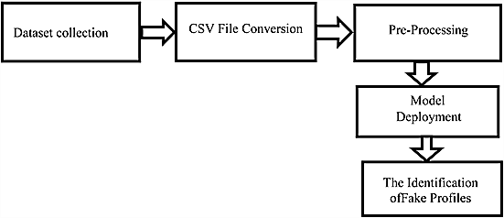

Fig.3.1 Proposed Method
In this project, we intend to give a framework with which the automatic detection of fake profiles can be done so that the social life of people become secured and by using this automatic detection technique we can make it easier for the sites to manage the huge number of profiles, which can’t be done manually.
4.2 Limitations:
Because of Privacy Issues the Facebook dataset is very limited and a lot of details are not made public.
4.3 Advantages
- Increased accuracy: Neural networks can identify patterns in large amounts of data, making them effective at identifying fake profiles across multiple online social networks with a high level of accuracy.
- Automation: Once the model is trained, the process of identifying fake profiles can be automated, saving time and resources.

This work uses Artificial Neural Networks to identify whether given social network account details are from genuine or fake users. ANN algorithm will be trained with all previous users fake and genuine account dataset and then whenever we gave new test data then that ANN train model will be applied on new test data to identify whether given new account details are from genuine or fake users. Online social networks such as Facebook or Twitter contain user’s details and some malicious users will hack social network database to steal or breach users information, To protect users data we are using ANN Algorithm.
To train ANN algorithm we are using below details from social networks
Account_Age, Gender, User_Age, Link_Desc, Status_Count, Friend_Count, Location, Location_IP, Status
All fake users main intention is to send friend request to normal users to hack their machine or to steal their data and never they will have many number of posts or have many following friends and their account age also will have less number of years. By analysing this features Facebook will mark whether user profile is fake or genuine. This Facebook profile data we downloaded from Facebook website and using this data to train ANN model. Below are some values from profile dataset.
Account_Age, Gender, User_Age, Link_Desc, Status_Count, Friend_Count, Location, Location_IP, Status
10, 1, 22, 0, 1073, 237, 0, 0, 0
10, 0, 33, 0, 127, 152, 0, 0, 0
10, 1, 46, 0, 1601, 405, 0, 0, 0
10, 0, 25, 0, 704, 380, 0, 0, 0
7, 1, 34, 1, 64, 721, 1, 1, 1
7, 1, 30, 1, 69, 587, 1, 1, 1
7, 1, 36, 1, 61, 782, 1, 1, 1
7, 1, 52, 1, 96, 827, 1, 1, 1

In above dataset all bold names are the dataset column names and all integer values are the dataset values. As ANN will not take string value so we convert gender values to 0 or 1, if male value is 1 and if female value is 0. In above dataset last column give us information of fake or agenuine account if last column contains value 0 then account is genuine otherwise fake. All fake account will have less number of posts as their main intention is to send friend requests not posts, so by analysing this features Facebook mark that record with value 1 which means it’s a fake account. We are using above dataset to train ANN model and this dataset saved inside code ‘dataset’ folder. After building train model we input test data with account details and ANN will give result as fake or genuine. Below are some values from test data
Account_Age, Gender, User_Age, Link_Desc, Status_Count, Friend_Count, Location, Location_IP
10, 1, 44, 0, 280, 1273, 0, 0
10, 0, 54, 0, 5237, 241, 0, 0
7, 0, 42, 1, 57, 631, 1, 1
7, 1, 56, 1, 66, 623, 1, 1
In above test data STATUS column and its value is not there and ANN will predict status and give us result whether above test data is fake or genuine. In output we can see result of above test data as genuine or fake.
3.4 ANN algorithms details
To demonstrate how to build a ANN neural network based image classifier, we shall build a 6 layer neural network that will identify and separate one image from other. This network that we shall build is a very small network that we can run on a CPU as well. Traditional neural networks that are very good at doing image classification have many more parameters and take a lot of time if trained on normal CPU. However, our objective is to show how to build a real-world convolutional neural network using TENSORFLOW.
Neural Networks are essentially mathematical models to solve an optimization problem. They are made of neurons, the basic computation unit of neural networks. A neuron takes an input (say x), do some computation on it (say: multiply it with a variable w and adds another variable b) to produce a value (say; z= wx + b). This value is passed to a non-linear function called activation function (f) to produce the final output (activation) of a neuron. There are many kinds of activation functions. One of the popular activation function is Sigmoid. The neuron which uses sigmoid function as an activation function will be called sigmoid neuron. Depending on the activation functions, neurons are named and there are many kinds of them like RELU, TanH.
If you stack neurons in a single line, it’s called a layer; which is the next building block of neural networks. See below image with layers
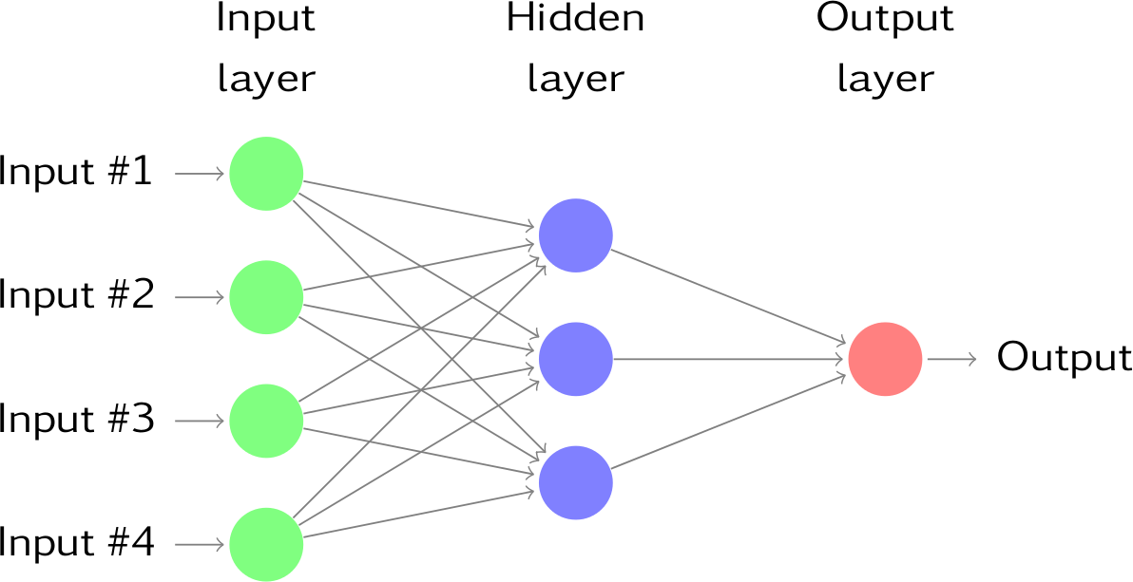
To predict class label multiple layers operate on each other to get best match layer and this process continues till no more improvement left.
3.5 Module Details
Upload Social Network Profiles Dataset: Using this module we will upload dataset to application
Pre-process Dataset: Using this module we will apply processing technique such as removing missing values and then split dataset into train and test where application use 80% dataset to train ANN and 20% dataset to test ANN prediction accuracy
Run ANN Algorithm: Using this module we will train ANN algorithm with train and test data and then train model will be generated and we can use this train model to predict fake accounts from new dataset.
ANN Accuracy & Loss Graph: To train ANN model we are taking 200 epoch/iterations and then in graph we will plot accuracy/loss performance of ANN at each epoch/iteration.
Predict Fake/Genuine Profile using ANN: using this module we will upload new test data and then apply ANN train model to predict whether test data is genuine or fake.

3.6 UML DIAGRAM

3.6.1 Class diagram
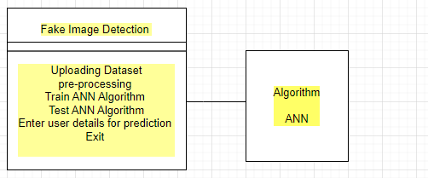
Fig.3.2 Class diagram
3.6.2 Use Case diagram
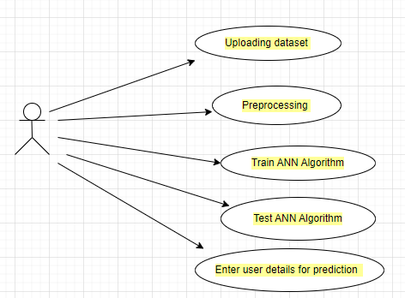
Fig.3.3 Use case diagram
3.6.3 Sequence diagram
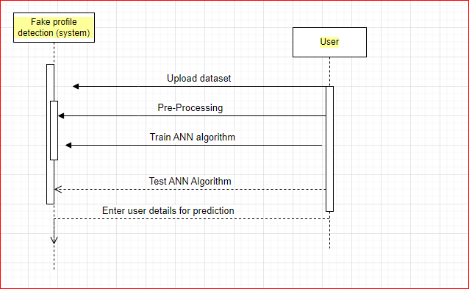
Fig.3.4 Sequence diagram
CHAPTER 6
HARDWARE AND SOFTWARE REQUIREMENTS
HARDWARE REQUIREMENTS:
- System : Pentium IV 2.4 GHz.
- Hard Disk : 40 GB.
- Floppy Drive : 1.44 Mb.
- Monitor : 15 VGA Colour.
- Mouse : Logitech.
- Ram : 512 Mb.
SOFTWARE REQUIREMENTS :
- Web technology : HTML, CSS, Java scripts, AJAX
- Python Web Server : Django
- Programming Language : Python
- Algorithm : Deep Neural Network
- Database : MYSQL

CHAPTER 5
RESULT
To run project double click on ‘run.bat’ file to get below screen
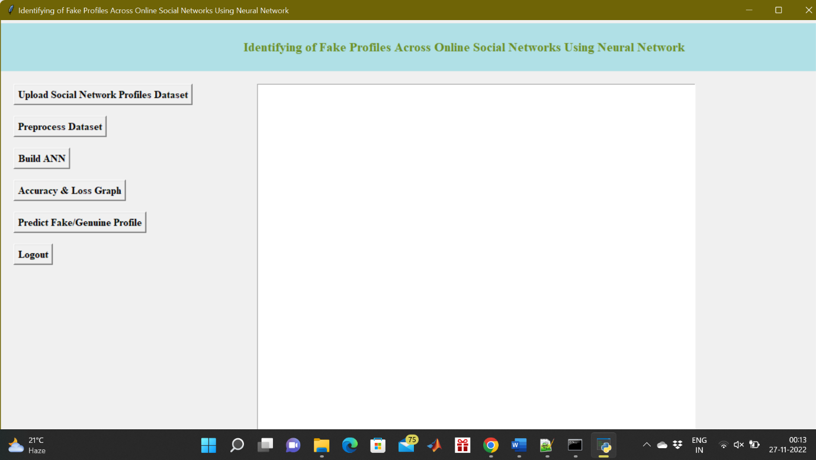
Fig.5.1 Upload Social Network Profiles Dataset
In above screen click on ‘Upload Social Network Profiles Dataset’ button and upload dataset
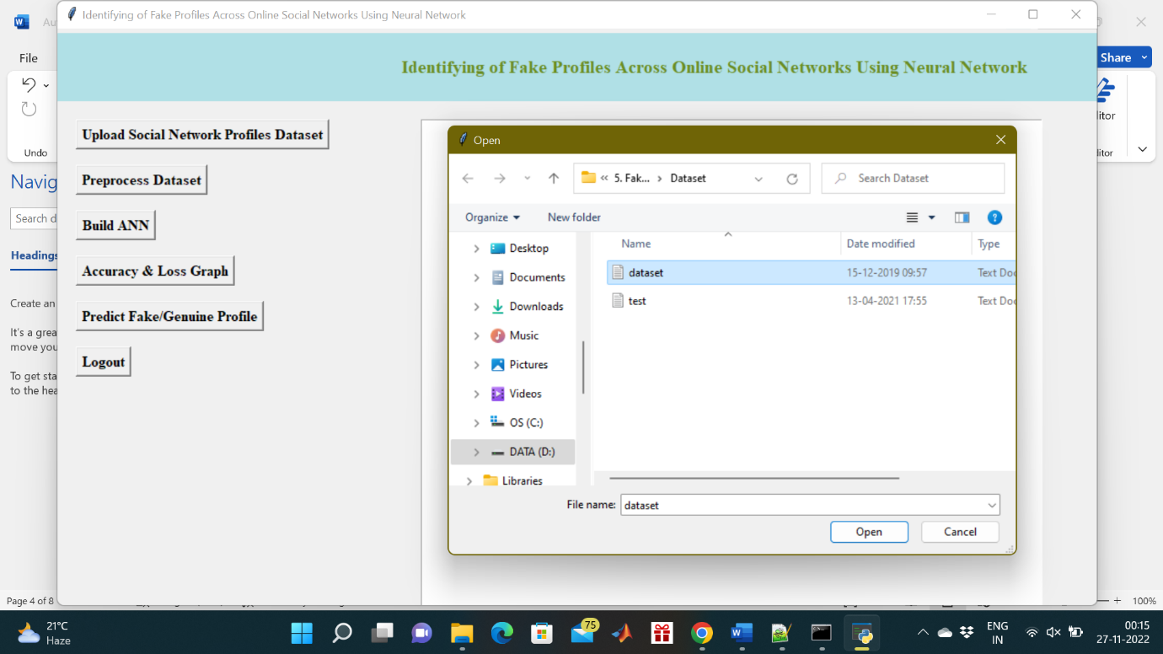
Fig.5.2 selecting and uploading ‘dataset.txt’ file
In above screen selecting and uploading ‘dataset.txt’ file and then click on ‘Open’ button to load dataset and to get below screen
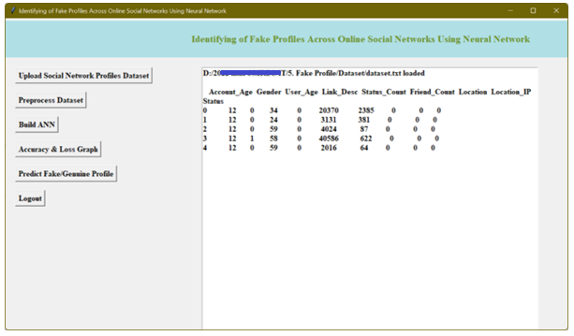
Fig.5.3 dataset loaded and displaying few records
In above screen dataset loaded and displaying few records from dataset and now click on ‘Preprocess Dataset’ button to remove missing values and to split dataset into train and test part
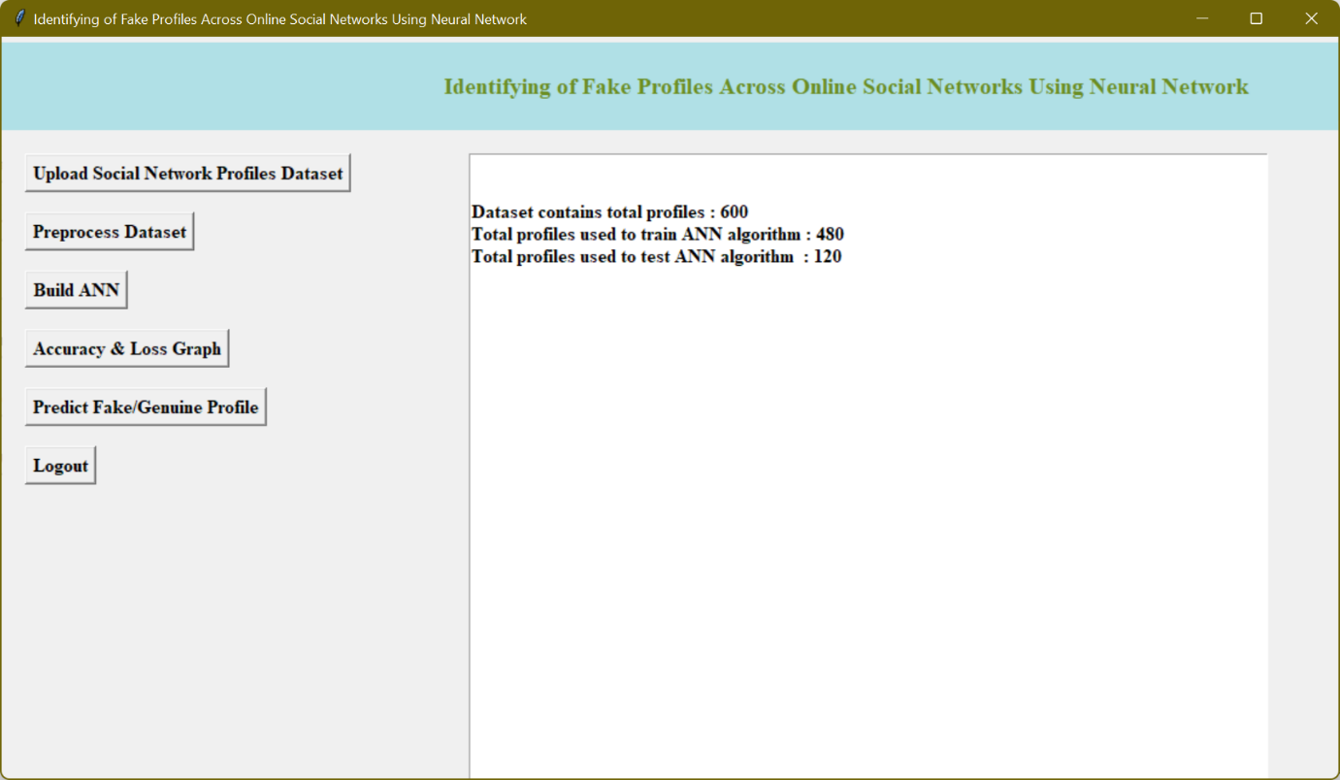
Fig.5.4 dataset contains total 600 records
In above screen we can see dataset contains total 600 records and application using 480 records for training and 120 records to test ANN and now dataset is ready and now click on ‘Run ANN Algorithm’ button to ANN algorithm
In below screen we can see ANN start iterating model generation and at each increasing epoch we can see accuracy is getting increase and loss getting decrease.
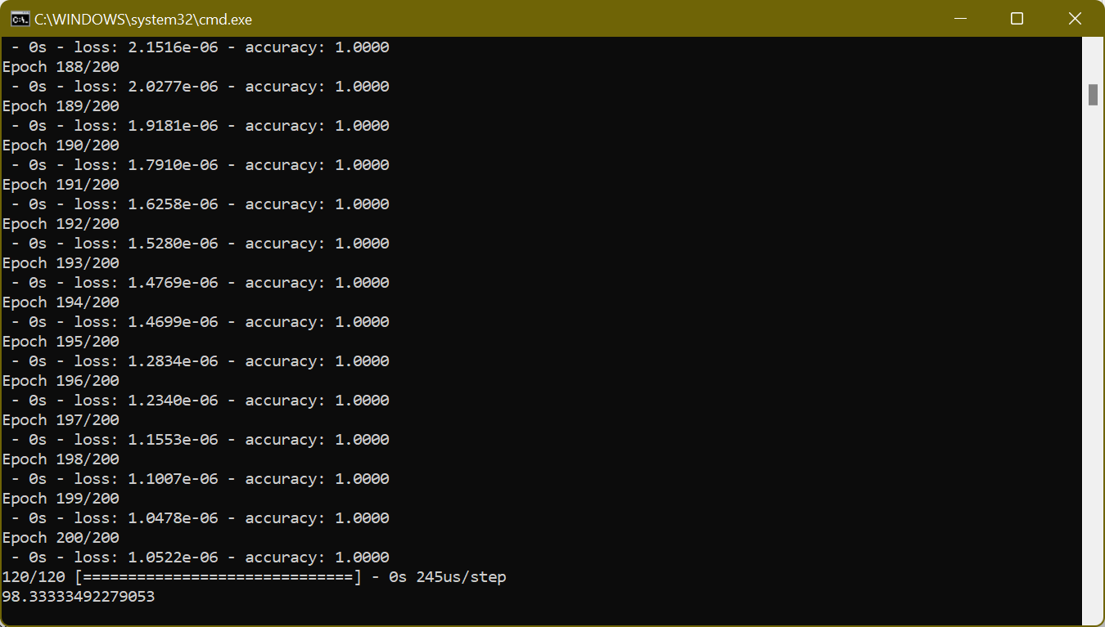
Fig.5.5 after 200 epoch ANN got 98.33% accuracy
In above screen we can see after 200 epoch ANN got 98.33% accuracy and in below screen we can see final ANN accuracy
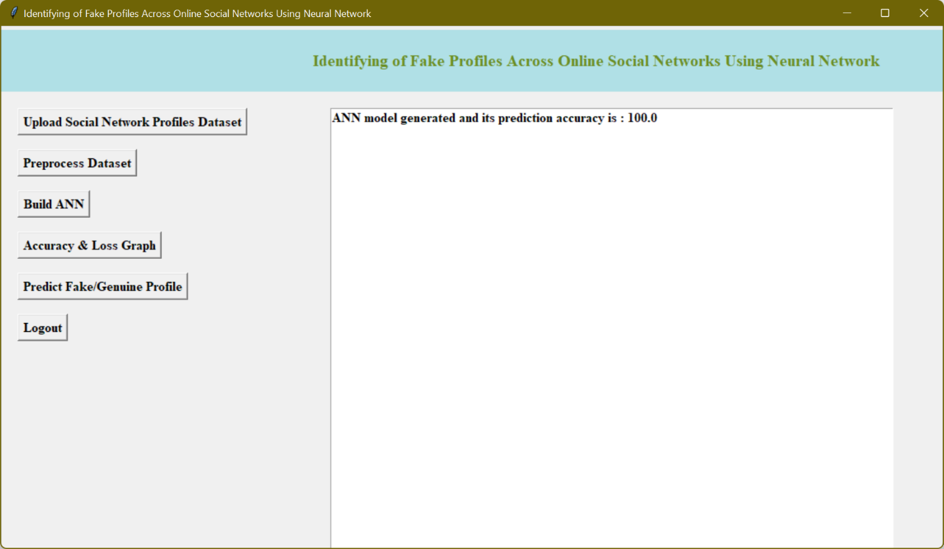
Fig.5.6 ANN model generated
In above screen ANN model generated and now click on ‘ANN Accuracy & Loss Graph’ button to get below graph
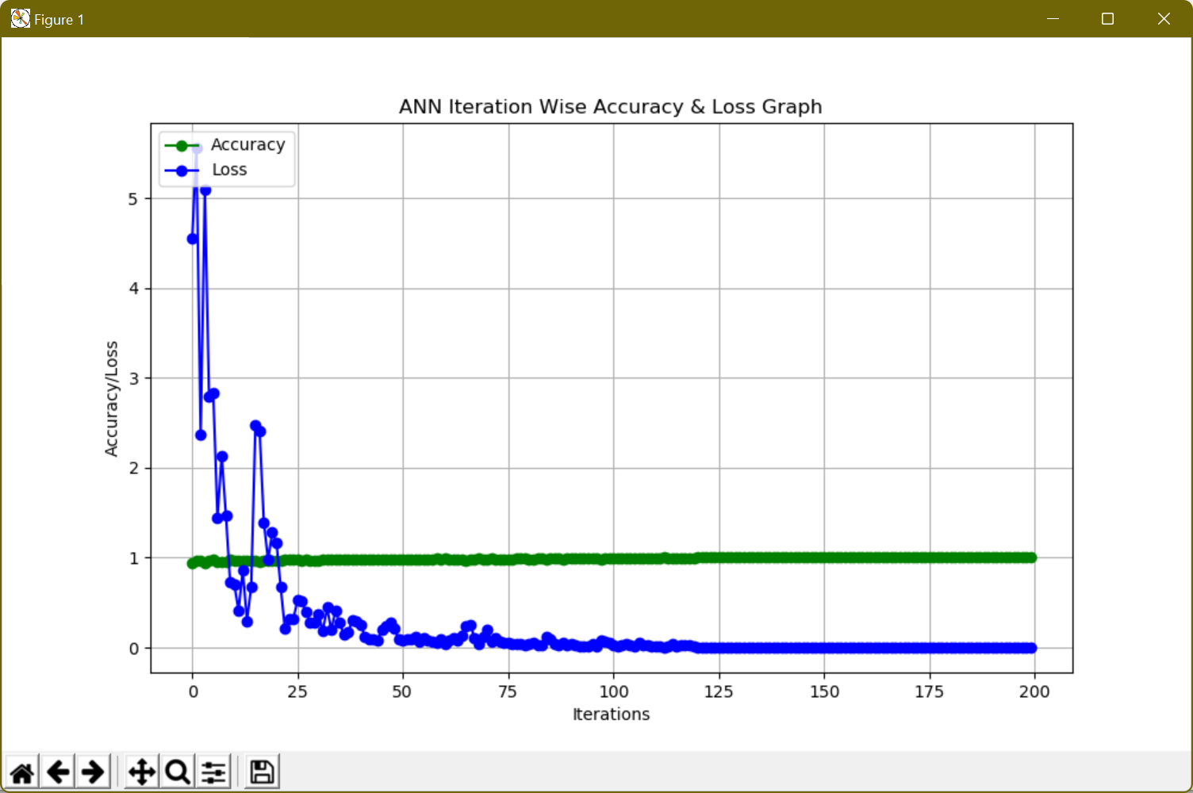
Fig.5.7 ANN Iteration wise accuracy and loss graph
In above graph x-axis represents epoch and y-axis represents accuracy/loss value and in above graph green line represents accuracy and blue line represents loss value and we can see accuracy was increase from 0.90 to 1 and loss value decrease from 7 to 0.1. Now model is ready and now click on ‘Predict Fake/Genuine Profile using ANN’ button to upload test data and then ANN will predict below result
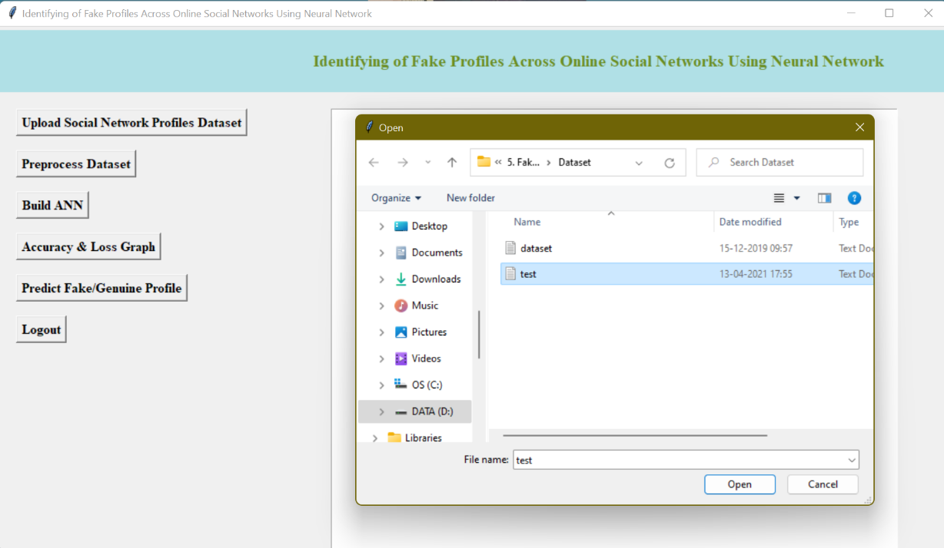
Fig.5.8 selecting and uploading ‘test.txt’ file
In above screen we are selecting and uploading ‘test.txt’ file and then click on ‘Open’ button to load test data and to get below prediction result
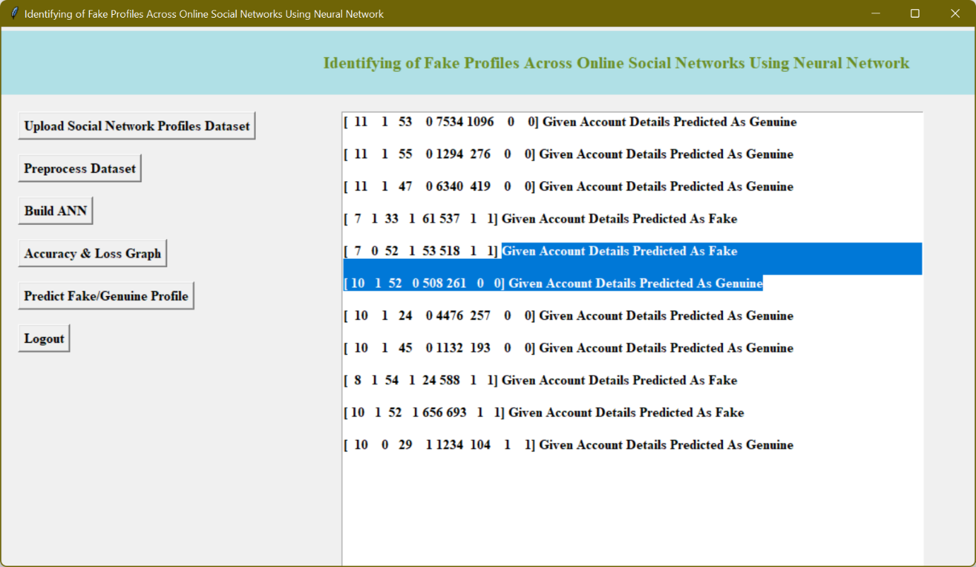
Fig.5.9 uploaded test data and after square bracket
In above screen in square bracket, we can see uploaded test data and after square bracket we can see ANN prediction result as genuine or fake

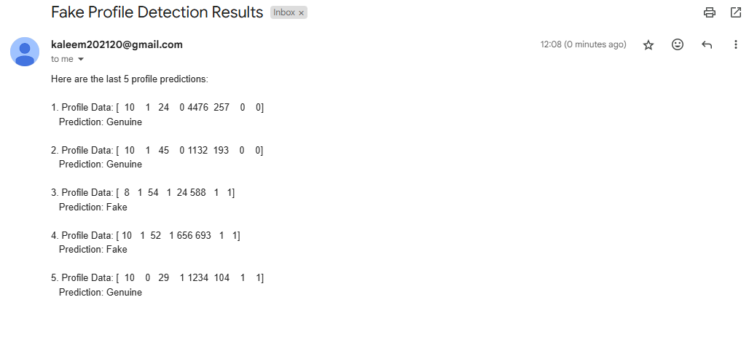
Fig: Output in Gmail
It will send results to admin/system when their email id is entered.

CHAPTER 6
APPLICATIONS
The application of identifying fake profiles across online social networks using neural networks involves using a neural network model to automatically detect and classify fake or fraudulent user profiles. Some of the applications of this approach are as follows:
- Social Media Platforms
- User Safety and Privacy
- Brand Protection
- Fraud Prevention
- Advertising Targeting
- Law Enforcement
- User Trust and Engagement

CHAPTER 7
CONCLUSION
In this paper, we use machine learning, namely an artificial neural network to determine what are the chances that a friend request is authentic are or not. Each equation at each neuron (node) is put through a Sigmoid function. We use a training data set by Facebook or other social networks. This would allow the presented deep learning algorithm to learn the patterns of bot behavior by back propagation, minimizing the final cost function and adjusting each neuron's weight and bias. In this paper, we outline the classes and libraries involved. We also discuss the sigmoid function and how are the weights determined and used. We also consider the parameters of the social network page which are the most important to our solution
Future scope
The current developed software is installed on the system, i.e. it is a desktop application, and it will be used for some institute. But later it can be updated so that it will be operate as online application. Currently, the system has reached up to some great accuracy level for partial and dense images. It can further be improved to obtain higher accuracy level.It can be automatically updated by the use of the concept of Internet of Things. The future scope of the project can be integrated with the hardware components for example Additionally, an application can be developed to find fake accounts and to maintain a track of online profiles.

REFERENCES
- Sai Pooja, G., Rajarajeswari, P., Yamini Radha, V ., Navya Krishna.G., Naga Sri Ram.B., Recognition of fake currency note using convolutional neural networks(2016). International Journal of Innovative Technology and Exploring Engineering, 58-63,8(5).
- Mohammed Ali Al-Garadi,Mohammad Rashid Hussain, Henry Friday Nweke, Ihsanali,Ghulammujtaba1,Harunachiro Ma,Hasanalikhattak,Andabdullahgani "Predicti-Ngcyber Bullying On Social Networks.
- Yadongzhou,Daewookkim,Junjiezhang,( Member,Ieee),Lili Liu1, Huanjin3, "(IEEE)ProGuard: Detecting Malicious Accounts in Social Network-Based Online Promotions".
- Mauro Conti University of Padua, Radha Poovendran University of Washington, Marco Secchiero University of Padua,"FakeBook: Detecting Fake Profiles in On- line Social Networks(2012)", ACM /IEEE International Conference on Advances in Social Networks Analysis and Mining.
- ni .N., Smruthi.M.,"A Hybrid Scheme for Detecting FakeAccounts in Facebook" ISSN: 2277- 3878, (IJRTE)International Journal of Recent Technology and Engineering (2019) , Issue-5S3, Volume-7.
- NarsimhaGugulothu,JayadevGyani, Srinivas Rao Pulluri "A Comprehensive Model for Detecting Fake Profiles in Online Social Networks(2016)".
- Dr.Narsimha.G, Dr.JayadevGyani, P. Srinivas Rao ,"Fake Profiles Identification in Online Social Networks Using Machine Learning and NLP(2018)", International Journal of Applied Engineering Research ISSN 0973-4562, Number 6, Volume 13.
- Reddy, A. V. N., &Phanikrishna, C. Contour tracking based knowledge extraction and object recognition using deep learning neural networks(2016). Paper presented at the Proceedings on 2nd International Conference on Next Generation Computing Technologies in 2016, NGCT 2016, 352-354. doi:10.1109/NGCT.2016.7877440.
- V. Rama Krishna,& K.Kanaka Durga. Automatic detection of illegitimate websites with mutual clustering.(2016) International Journal of Electrical and Computer Engineering, 6(3), 995-1001. doi:10.11591/ijece.v6i3.9878
- D.Rajeswara Rao & V.Pellakuri. Training and development of artificial neural network models: Single layer feedforward and multi layer feedforward neural network(2016). Journal of Theoretical and Applied Information Technology, 150-156,84(2).
- Qiang Cao, Michael Sirivianos, Xiaowei Yang, and Tiago Pregueiro. 2012. Aiding the detection of fake accounts in large scale social online services. In Proceedings of the 9th USENIX conference on Networked Systems Design and Implementation (NSDI'12). USENIX Association, Berkeley, CA, USA, 15-15.
- Akshay J. Sarode and Arun Mishra. 2015. Audit and Analysis of Impostors: An experimental approach to detect fake profile in an online social network. In Proceedings of the Sixth International Conference on Computer and Communication Technology 2015 (ICCCT '15). ACM, New York, NY, USA, 1-8. DOI: https://doi.org/10.1145/2818567.28185 68
- Devakunchari Ramalingam, Valliyammai Chinnaiah. Fake profile detection techniques in large-scale online social networks: A comprehensive review. Computers & Electrical Engineering, Volume 65, 2018, Pages 165-177, ISSN 0045- 7906, https://doi.org/10.1016/j.compeleceng. 2017.05.020.
- Challa, N.,. Pasupuleti, S. K, & Chandra, J. V. A practical approach to E-mail spam filters to protect data from advanced persistent threat.(2016) Paper presented at the Proceedings of IEEE International Conference on Circuit, Power and Computing Technologies, ICCPCT 2016, doi:10.1109/ICCPCT.2016.7530239.
- D.Rajeswara Rao , & P.Vidyullatha. Machine learning techniques on multidimensional curve fitting data based on r_ square and chi_square methods(2016). International Journal of Electrical and Computer Engineering, . doi:10.11591/ijece.v6i3.91556(3), 974- 979.
- K.Anand., & J.Kumar, Anomaly detection in online social network: A survey. Paper presented at the Proceedings of the(2017) International Conference on Inventive Communication and Computational Technologies,ICICCT 2017, 456-459. doi:10.1109/ICICCT.2017.7975239
- Pradeepini, G., Patil, S. T. ,& Bangare, S. L (2017). Brain tumor classification using mixed method approach. Paper presented at the International Conference on Information Communication and Embedded Systems, ICICES, doi:10.1109/ICICES.2017.8070748
- Jaya Lakshmi, R., &Subba Rao, G. V. A re- constructive algorithm to improve image recovery in compressed sensing. Journal of Theoretical and Applied Information Technology(2017), 95(20), 5443- 5453
- N.Jayanthi, B.V.Babu., & N.S.Rao,. Survey on clinical prediction models for diabetes prediction. Journal of Big Data, 4(1) 2017 doi:10.1186/s40537-017-0082-7
- .Pradeepini, G., Pradeepa, G., Tejanagasri, B., &Gorrepati, S. H. Data classification and personal care management system by machine learning approach. International Journal of Engineering and Technology,2018 (UAE), 7(2.32 Special Issue 32), 219-223. doi:10.22444/IBVS.6227_old
- .Praveena, M., Asha Deepika, R., & Sai Raghavendhar, C. Analysis on prediction of heart disease using data mining techniques. Journal of Advanced Research in Dynamical and Control Systems(2018), 10(2), 126-136.
- Satish Babu, J., Niveditha, M., Bhavya, V., &Gowthami, K. Data mining techniques for herbs. International Journal of Engineering and Technology,2018(UAE), 7(1.1 Special Issue 1), 406- 410.
- Shinde, S. A., &Rajeswari, P. R. Intelligent health risk prediction systems using machine learning: A review. International Journal of Engineering and Technology,2018(UAE), 7(3), 1019- 1023. doi:10.14419/ijet.v7i3.12654
- Sucharitha, G., &Senapati, R. K. Local extreme edge binary patterns for face recognition and image retrieval(2018). Journal of Advanced Research in Dynamical and Control Systems_10, 644-654.
- V.N.Mandhala, D.Bhattacharyya, &T.Kim . Face detection using image morphology - A review. International Journalof Security and its Applications,2016, 10(4), 89-94. doi:10.14257/ijsia.2016.10.4.10
- Awasthi, S., Shanmugam, R., Jena, S.R. and Srivastava, A., 2020. Review of Techniques to Prevent Fake Accounts on Social Media.
- .Hajdu, G., Minoso, Y., Lopez, R., Acosta, M. and Elleithy, A., 2019, May. Use of Artificial Neural Networks to Identify Fake Profiles. In2019 IEEE Long Island Systems, Applications and Technology Conference (LISAT)(pp. 1-4). IEEE.
- .Kaur, J. and Sabharwal, M., 2018. Spam detection in online social networks using feed forward neural network. InRSRI conference on recent trends in science and engineering(Vol. 2, pp. 69-78).
- .Khaled, S., El-Tazi, N. and Mokhtar, H.M., 2018, December. Detecting fake accounts on social media. In2018 IEEE International Conference on Big Data (Big Data)(pp. 3672-3681). IEEE.
- .Meligy, A.M., Ibrahim, H.M. and Torky, M.F., 2017. Identity verification mechanism for detecting fake profiles in online social networks.Int. J. Comput. Netw. Inf. Secur.(IJCNIS),9(1), pp.31-39.
- .Ramalingam, D. and Chinnaiah, V., 2018. Fake profile detection techniques in large-scale online social networks: A comprehensive review.Computers & Electrical Engineering,65, pp.165-177
- Wanda, P. and Jie, H.J., 2020. DeepProfile: Finding fake profile in online social network using dynamic CNN.Journal of Information Security and Applications,52, p.102465.
- Zhang, J., Dong, B. and Philip, S.Y., 2020, April. Fakedetector: Effective fake news detection with deep diffusive neural network. In2020 IEEE 36th International Conference on Data Engineering (ICDE)(pp. 1826-1829). IEEE

APPENDIX
PYTHON
1.1 Introduction
* One of the most popular languages is Python. Guido van Rossum released this language in 1991. Python is available on the Mac, Windows, and Raspberry Pi operating systems. The syntax of Python is simple and identical to that of English. When compared to Python, it was seen that the other language requires a few extra lines.
*It is an interpreter-based language because code may be run line by line after it has been written. This implies that rapid prototyping is possible across all platforms. Python is a big language with a free, binary-distributed interpreter standard library.
* It is inferior to maintenance that is conducted and is straightforward to learn. It is an object-oriented, interpreted programming language. It supports several different programming paradigms in addition to object-oriented programming, including functional and procedural programming.
* It supports several different programming paradigms in addition to object-oriented programming, including practical and procedural programming. Python is mighty while maintaining a relatively straightforward syntax. Classes, highly dynamic data types, modules, and exceptions are covered. Python can also be utilised by programmes that require programmable interfaces as an external language.
Here are some key features and characteristics of Python:
- Readability: Python emphasizes code readability with its clean and intuitive syntax. It uses indentation and whitespace to structure code blocks, making it easy to understand and maintain.
- Easy to Learn: Python's simplicity and readability make it an excellent choice for beginners. Its straightforward syntax and extensive documentation make it accessible for newcomers to programming.
- Interpreted Language: Python is an interpreted language, meaning that it doesn't need to be compiled before running. The Python interpreter reads and executes the code directly, making the development process faster and more interactive.
- Cross-platform Compatibility: Python is available for major operating systems like Windows, macOS, and Linux. This cross-platform compatibility allows developers to write code once and run it on different platforms without modifications.
- Large Standard Library: Python comes with a vast standard library that provides ready-to-use modules and functions for various tasks. It covers areas such as file I/O, networking, regular expressions, databases, and more, saving developers time and effort.
- Extensible and Modular: Python supports modular programming, enabling developers to organize code into reusable modules and packages. Additionally, Python allows integrating modules written in other languages, such as C or C++, providing flexibility and performance optimizations.
- Wide Range of Libraries and Frameworks: Python has a vibrant ecosystem with numerous third-party libraries and frameworks. These libraries, such as NumPy, pandas, TensorFlow, and Django, extend Python's capabilities for specific domains, making it a powerful tool for diverse applications.
- Object-Oriented: Python supports object-oriented programming (OOP) principles, allowing developers to create and work with classes and objects. OOP provides a structured approach to code organization, promoting code reuse and modularity.
- Dynamic Typing: Python is dynamically typed, meaning variable types are determined at runtime. Developers do not need to declare variable types explicitly, which enhances flexibility and simplifies code writing.
1.2 Installation
To install Python on your computer, follow these basic steps:
- Step 1: Visit the Python website Go to the official Python website at https://www.python.org/.
- Step 2: Select the operating system Choose the appropriate installer for your operating system. Python supports Windows, macOS, and various Linux distributions. Make sure to select the correct version that matches your operating system.
- Step 3: Check which version of Python is installed; if the 3.7.0 version is not there, uninstall it through the control panel and
- Step 4: Install Python 3.7.0 using Cmd.
- Step 5: Install the all libraries that required to run the project
- Step 6: Run
1.3 Python Features:
- Easy: Because Python is a more accessible and straightforward language, Python programming is easier to learn.
- Interpreted language: Python is an interpreted language, therefore it can be used to examine the code line by line and provide results.
- Open Source: Python is a free online programming language since it is open-source.
- Portable: Python is portable because the same code may be used on several computer standard
- libraries: Python offers a sizable library that we may utilize to create applications quickly.
- GUI: It stands for GUI (Graphical User Interface)
- Dynamical typed: Python is a dynamically typed language, therefore the type of the value will be determined at runtime.
1.4 Python GUI (Tkinter)
- Python provides a wide range of options for GUI development (Graphical User Interfaces).
- Tkinter, the most widely used GUI technique, is used for all of them.
- The Tk GUI toolkit offered by Python is used with the conventional Python interface.
- Tkinter is the easiest and quickest way to write Python GUI programs.
- Using Tkinter, creating a GUI is simple.
- A part of Python's built-in library is Tkinter. The GUI programs were created.
- Python and Tkinter together give a straightforward and quick way. The Tk GUI toolkit's object-oriented user interface is called Tkinter.

Making a GUI application is easy using Tkinter. Following are the steps:
1) Install the Tkinter module in place.
2) The GUI applicatioMakeske the primary window
3) Include one or more of the widgets mentioned above in the GUI application.
4) Set up the main event loop such that it reacts to each user-initiated event.
Although Tkinter is the only GUI framework included in the Python standard library, Python includes a GUI framework. The default library for Python is called Tkinter. Tk is a scripting language often used in designing, testing, and developing GUIs. Tk is a free, open-source widget toolkit that may be used to build GUI applications in a wide range of computer languages.

1.5 Python IDLE
- Python IDLE offers a full-fledged file editor, which gives you the ability to write and execute Python programs from within this program. The built-in file editor also includes several features, like code completion and automatic indentation, that will speed up your coding workflow.
- Guido Van Rossum named Python after the British comedy group Monty Python while the name IDLE was chosen to pay tribute to Eric Idle, who was one of the Monty Python's founding members. IDLE comes bundled with the default implementation of the Python language since the 01.5. 2b1 release
- IDLE is used to execute statements similar to Python Shell. IDLE is used to create, modify, and execute Python code. IDLE provides a fully-featured text editor to write Python scripts and provides features like syntax highlighting, auto-completion, and smart indent.
- IDLE has two modes: interactive and script. We wrote our first program, “Hello, World!” in interactive mode. Interactive mode immediately returns the results of commands you enter into the shell. In script mode, you will write a script and then run it.
- The IDE Python IDLE is a good place to start as it helps you become familiar with the way Python works and understand its syntax. This IDE is good to start programming in Python due to its great debugger, but once you are fluent and start developing projects it is necessary to jump to another, more complete IDE.
- Python IDLE (Integrated Development and Learning Environment) is an interactive development environment included with the Python programming language. It provides a convenient way to write, execute, and debug Python code.
When you install Python, IDLE is typically installed along with it. To open IDLE, you can follow these steps:
- Open the command prompt (Windows) or terminal (macOS/Linux).
- Type "idle" and press Enter. Alternatively, you can specify the version with "idle3" or "idle2" for Python 3 or Python 2, respectively.
- Once IDLE is launched, you will see the Python shell, which is an interactive environment where you can type and execute Python code directly.
Here are some features and functionalities provided by Python IDLE:
- Editor: IDLE includes a text editor where you can write your Python code. It offers syntax highlighting, automatic indentation, and code completion to enhance your coding experience.
- Interactive Shell: The Python shell in IDLE allows you to execute Python code interactively. You can type commands, statements, or function calls directly in the shell, and Python will execute them immediately.
- Debugging: IDLE provides basic debugging capabilities to help you find and fix errors in your code. You can set breakpoints, step through code, inspect variables, and track the program's execution.
- Python Help: IDLE provides access to the Python documentation and built-in help. You can access the help menu to find information about Python modules, functions, classes, and more.
- Script Execution: In addition to the interactive shell, IDLE allows you to run Python scripts stored in files. You can write your code in the editor and execute it as a script to see the output or interact with the program.
- Customization: IDLE can be customized to suit your preferences. You can modify settings related to syntax highlighting, indentation, fonts, and more.
- Python IDLE serves as a beginner-friendly development environment and learning tool. It is suitable for writing small scripts, testing code snippets, experimenting with Python features, and learning the language's basics. However, for more advanced development projects, you may consider using other code editors or integrated development environments (IDEs) that provide additional features and better project management capabilities.
1.6 Libraries
In Python, libraries (also referred to as modules or packages) are collections of pre-written code that provide additional functionality and tools to extend the capabilities of the Python language. Libraries contain reusable code that developers can leverage to perform specific tasks without having to write everything from scratch.
Python libraries are designed to solve common problems, such as handling data, performing mathematical operations, interacting with databases, working with files, implementing networking protocols, creating graphical user interfaces (GUIs), and much more. They provide ready-to-use functions, classes, and methods that simplify complex operations and save development time.
Libraries in Python offer various advantages:
- Code Reusability:
- Efficiency:
- Collaboration
- Domain-Specific Functionality
- To use a Python library, you need to install it first.
There are some libraries following:
- Pandas:
Pandas are a Python computer language library for data analysis and manipulation. It offers a specific operation and data format for handling time series and numerical tables. It differs significantly from the release3-clause of the BSD license. It is a well-liked open-source of opinion that is utilized in machine learning and data analysis.
Pandas are a Python package providing fast, flexible, and expressive data structures designed to make working with “relational” or “labeled” data both easy and intuitive. It aims to be the fundamental high-level building block for doing practical, real-world data analysis in Python. Pandas are a Python library used for working with data sets.
- It has functions for analysing, cleaning, exploring, and manipulating data.
- The name "Pandas" has a reference to both "Panel Data", and "Python Data Analysis" and was created by Wes McKinney in 2008.
- Pandas allow us to analyse big data and make conclusions based on statistical theories.
- Pandas can clean messy data sets, and make them readable and relevant.
Relevant data is very important in data science. Pandas are a Python library for data analysis. Started by Wes McKinney in 2008 out of a need for a powerful and flexible quantitative analysis tool, pandas have grown into one of the most popular Python libraries. It has an extremely active community of contributors. The name is derived from the term "panel data", an econometrics term for data sets that include observations over multiple time periods for the same individuals. Its name is a play on the phrase "Python data analysis" itself.
- NumPy:
The NumPy Python library for multi-dimensional, big-scale matrices adds a huge number of high-level mathematical functions. It is possible to modify NumPy by utilizing a Python library. Along with line, algebra, and the Fourier transform operations, it also contains several matrices-related functions.
NumPy can be used to perform a wide variety of mathematical operations on arrays. It adds powerful data structures to Python that guarantee efficient calculations with arrays and matrices and it supplies an enormous library of high-level mathematical functions that operate on these arrays and matrices.
- NumPy is a Python library used for working with arrays.
- It also has functions for working in domain of linear algebra, Fourier transform, and matrices.
- NumPy was created in 2005 by Travis Oliphant. It is an open source project and you can use it freely.
- NumPy stands for Numerical Python.
- In Python we have lists that serve the purpose of arrays, but they are slow to process.
- NumPy aims to provide an array object that is up to 50x faster than traditional Python lists.
- The array object in NumPy is called ndarray, it provides a lot of supporting functions that make working with ndarray very easy.
- Arrays are very frequently used in data science, where speed and resources are very important.

- Matplotlib:
It is a multi-platform, array-based data visualization framework built to interact with the whole SciPy stack. MATLAB is proposed as an open-source alternative. Matplotlib is a Python extension and a cross-platform toolkit for graphical plotting and visualization.
Matplotlib is a popular Python library for creating static, animated, and interactive visualizations. It provides a flexible and comprehensive set of tools for generating plots, charts, histograms, scatter plots, and more. Matplotlib is widely used in various fields, including data analysis, scientific research, and data visualization.
Here are some key features and functionalities of the Matplotlib library:
- Plotting Functions
- Customization Options
- Multiple Interfaces
- Integration with NumPy and pandas
- Subplots and Figures:
- Saving and Exporting

- Scikit-learn:
The most stable and practical machine learning library for Python is scikit-learn. Regression, dimensionality reduction, classification, and clustering are just a few of the helpful tools it provides through the Python interface for statistical modeling and machine learning. It is an essential part of the Python machine learning toolbox used by JP Morgan. It is frequently used in various machine learning applications, including classification and predictive analysis.
Scikit-learn (also referred to as sklearn) is a widely used open-source machine learning library for Python. It provides a comprehensive set of tools and algorithms for various machine learning tasks, including classification, regression, clustering, dimensionality reduction, model selection, and pre-processing.
Here are some key features and functionalities of the Scikit-learn library:
- Easy-to-Use Interface:
- Broad Range of Algorithms:
- Data Pre-processing and Feature Engineering:
- Model Evaluation and Validation:
- Integration with NumPy and pandas:
- Robust Documentation and Community Support:

- Keras:
* Google's Keras is a cutting-edge deep learning API for creating neural networks. It is created in Python and is designed to simplify the development of neural networks. Additionally, it enables the use of various neural networks for computation. Deep learning models are developed and tested using the free and open-source Python software known as Keras.
Keras is a high-level deep learning library for Python. It is designed to provide a user-friendly and intuitive interface for building and training deep learning models. Keras acts as a front-end API, allowing developers to define and configure neural networks while leveraging the computational backend engines, such as Tensor Flow or Theano.
Here are some key features and functionalities of the Keras library:
- User-Friendly API
- Multi-backend Support
- Wide Range of Neural Network Architectures
- Pre-trained Models and Transfer Learning:
- Easy Model Training and Evaluation:
- GPU Support:

- h5py:
* The h5py Python module offers an interface for the binary HDF5 data format. Thanks to p5py, the top can quickly halt the vast amount of numerical data and alter it using the NumPy library. It employs common syntax for Python, NumPy, and dictionary arrays.
h5py is a Python library that provides a simple and efficient interface for working with datasets and files in the Hierarchical Data Format 5 (HDF5) format. HDF5 is a versatile data format commonly used for storing and managing large volumes of numerical data.
Here are some key features and functionalities of the h5py library:
  - HDF5 File Access
  - Dataset Handling:
  - Group Organization:
  - Attributes:
  - Compatibility with NumPy
  - Performance

- Tensor flow
TensorFlow is a Python library for fast numerical computing created and released by Google. It is a foundation library that can be used to create Deep Learning models directly or by using wrapper libraries that simplify the process built on top of TensorFlow. TensorFlow is an end-to-end open source platform for machine learning. TensorFlow is a rich system for managing all aspects of a machine learning system; however, this class focuses on using a particular TensorFlow API to develop and train machine learning models.
TensorFlow is a popular open-source library for machine learning and deep learning. It provides a comprehensive set of tools, APIs, and computational resources for building and training various types of machine learning models, especially neural networks.
Here are some key features and functionalities of TensorFlow:
- Neural Network Framework:
- Computational Graphs
- Automatic Differentiation
- GPU and TPU Support
- Distributed Computing
- Deployment Capabilities

- Tkinter
Tkinter is an acronym for "Tk interface". Tk was developed as a GUI extension for the Tcl scripting language by John Ousterhout. The first release was in 1991. Tkinter is the de facto way in Python to create Graphical User interfaces (GUIs) and is included in all standard Python Distributions. In fact, it's the only framework built into the Python standard library.
Tkinter is a standard Python library used for creating graphical user interfaces (GUIs). It provides a set of modules and classes that allow you to develop interactive and visually appealing desktop applications.
Here are some key features and functionalities of Tkinter:
- Cross-Platform Compatibility
- Simple and Easy-to-Use
- Widgets and Layout Management
- Event-Driven Programming
- Customization and Styling
- Integration with Other Libraries

- NLTK
NLTK is a toolkit build for working with NLP in Python. It provides us various text processing libraries with a lot of test datasets. A variety of tasks can be performed using NLTK such as tokenizing, parse tree visualization, etc NLTK (Natural Language Toolkit) is the go-to API for NLP (Natural Language Processing) with Python. It is a really powerful tool to pre-process text data for further analysis like with ML models for instance. It helps convert text into numbers, which the model can then easily work with.
NLTK (Natural Language Toolkit) is a Python library widely used for working with human language data and implementing natural language processing (NLP) tasks. It provides a set of tools, corpora, and resources for tasks such as tokenization, stemming, tagging, parsing, sentiment analysis, and more.
Here are some key features and functionalities of NLTK:
- Text Processing
- Part-of-Speech Tagging
- Named Entity Recognition
- Chunking and Parsing
- Sentiment Analysis:
- WordNet Integration:

- Scipy
SciPy is a collection of mathematical algorithms and convenience functions built on the NumPy extension of Python. It adds significant power to the interactive Python session by providing the user with high-level commands and classes for manipulating and visualizing data.
SciPy is a powerful scientific computing library for Python that provides a wide range of mathematical algorithms and functions. It builds upon NumPy, another fundamental library for numerical computing, and extends its capabilities by adding additional tools for scientific and technical computing tasks.
Here are some key features and functionalities of SciPy:
- Numerical Integration:
- Optimization and Root Finding
- Linear Algebra
- Signal and Image Processing
- Statistics

